Qualification Test for Welders
and Welding Procedures
Date:
Company: |  |  |  |  |  |  |  |  |  |  |  |  |  |  | Location:
Name of Person to be Qualified:
Reinforcing Steel Manufacturer:
Identifying Bar Making:
Size of Reinforcing Bars: |  |  |  |  |  |  |  |  |  |  | Longitudinal: |  |  |  |  |  |  |  | Vertical:
Position of Welding*: Flat Vertical-up
Welding Machine and settings:
Amperage: |  |  |  |  |  |  |  |  | Polarity: Straight Reverse Current: AC DC
Welding Rod: |  |  |  | Type: |  |  |  |  |  |  |  | Mfg. |  |  |  | Mfg. Designation |  |  |  |  |  | Size
Samples marked as follows:
Remarks:
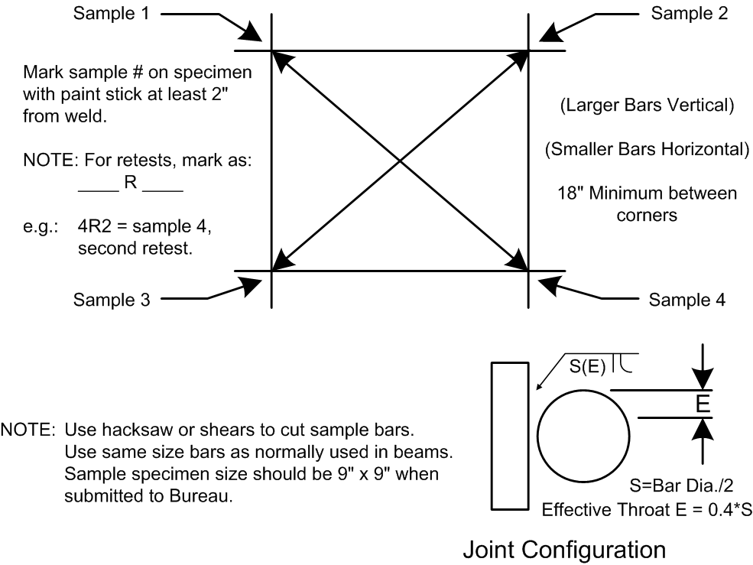

Note: If joint configuration detail has vertical bar to left, weld position is flat (downhand) and welder/weld procedure is only qualified for flat. If joint configuration detail has horizontal bar to left, then weld must be vertical-up and welder/weld procedure is qualified for flat or vertical-up.
IDOT Inspector Name (Print)
IDOT Inspector Signature

