Bridge Inspection System (BIS)
User Manual/Flash Sheets
July 2020

Contents
Create an Inspector Account 3
Open a Structure 9
Search/Assignment 15
Create a New Inspection 19
Routine Inspection 20
Fracture Critical Inspection 21
Underwater Inspection 23
Special Inspection 24
Element Level Inspection 25
Approve an Inspection 28
Create a Review List 29
Create a Work Item 31
Email a work item 31
Print an Inspection 32
Upload a file 33
Structure Level 33
Inspection Level 35
Work Items Level 37
Training Class Level 40
View and download files 42
General Notes 43
Required Fields 43
New: Data Entry 44
Allow Pop Ups 45
Additional Table Functions 46
Inspection Approval Messages 49

Create an Inspector Account

Create a New Login Account
To enter the IHIS/BIS application, each user must have their own account, to provide correct security preferences and privileges for an individual. Each user must have their own unique login credentials and must not share a “common” account. All data entered into IHIS/BIS is electronically signed using your login credentials.
To create a new BIS account, you need to create either a login for your Active Directory account or a Microsoft account. For the Microsoft account, you can use an existing personal email address.

Active Directory Account
If your organization uses Microsoft 365 (aka Office 365), then you can login to IHIS/BIS using your own network credentials. If you are not sure if your organization uses Microsoft 365, there is no harm in trying the Active Directory option to see if it works.
To use an Active Directory account, you can begin from the initial BIS login screen, and select the Active Directory option.
- Enter the BIS URL into a browser window (works best with Google Chrome)
- Click the Active Directory button in the Sign In section

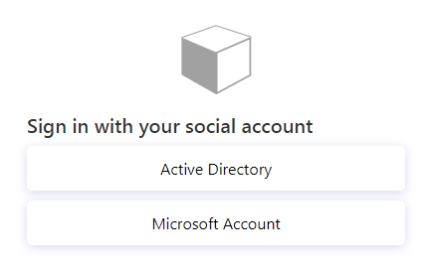

- On the Sign In screen, enter the email address for the user, then click Next

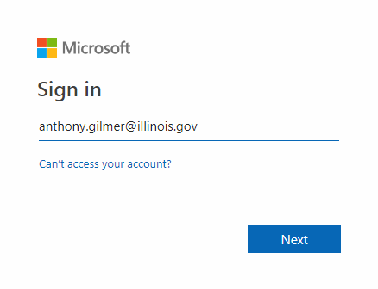

- On the following screen, you will get a screen requesting your password. In some cases, this may be a custom screen provided by your organization. Below is an example that an Illinois.gov user would see.
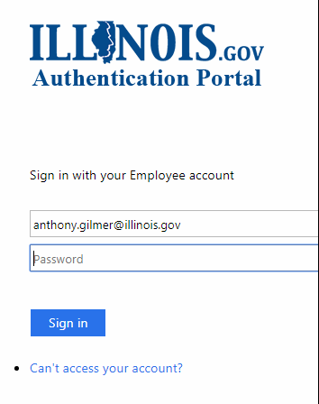

Microsoft Account
If your organization does not use Microsoft 365, the alternate login method is a Microsoft Account. You can register a Microsoft Account for any email address which is not also used for Microsoft 365.
To create a Microsoft account, you can begin from the initial BIS login screen, and select the Microsoft Account option
- Enter the BIS URL into a browser window (works best with Google Chrome)
- Click the Microsoft Account button in the Sign In section
- On the Sign In screen, click the “Create one!” link to begin a new account
  - If you already have a Microsoft account, login using the Next button and skip to step 11.
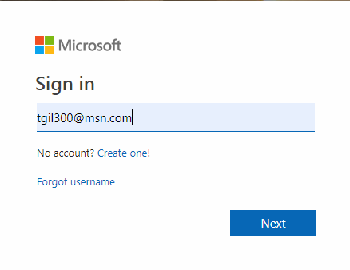

- On the Create Account screen, enter the email address for the new user, then click Next.
(Do not use a Phone Number)
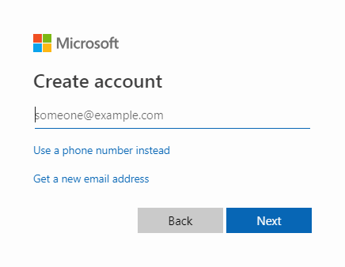
- Enter the new password into the Create Password field, then click Next
- Enter the first and Last Name of the new Inspector, then click Next
- Enter the Country/Region & Birthdate of the user, then click Next
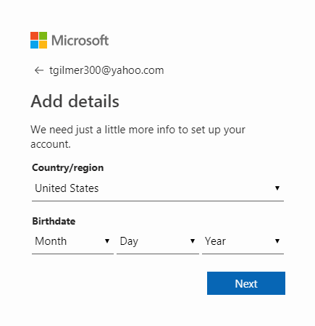

- To verify the user’s email address, enter the code sent the newly registered email address, then click Next
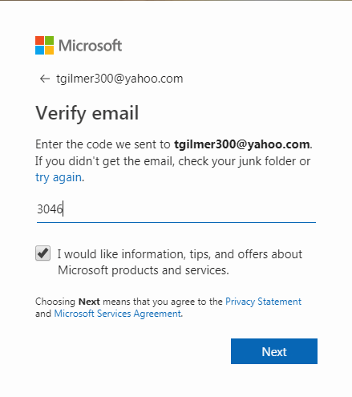
- On the next Create Account screen, enter the provided characters in the field, then click Next
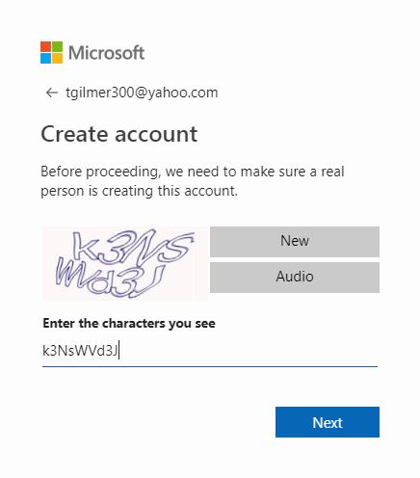
- Verify if the security information that you provided was entered correctly
  - If correct, click the “Looks Good!” option
  - If not, click the “Update Now” option to correct the information
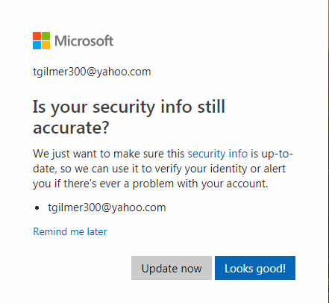
- To allow the application to access your new account, click “Yes” to provide permission
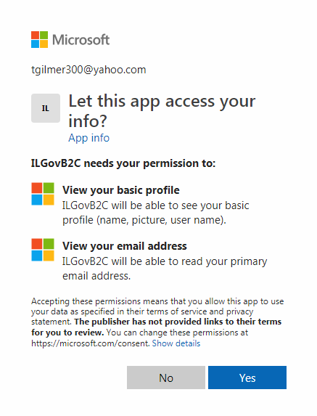

- Enter the information you’d like to have displayed for the new account, then click Continue
  - If email address isn’t verified, click the “Send Verification Code” button
  - “Job Title” can be changed later, under the Inspector Qualifications screen
Enter profile information
A screen will appear after your first successful login. Information entered on this screen is used to help identity your user. If you used a Microsoft Account, you may need to provide a verification code on this screen as well.
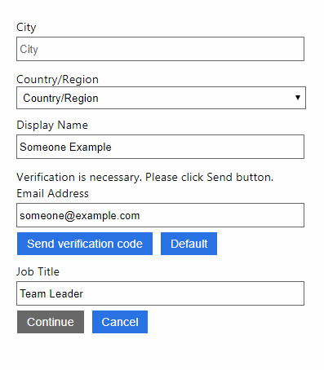
Request access
Once you have successfully logged in, you may see the following screen. Please follow the directions on the screen to request access to IHIS/BIS.
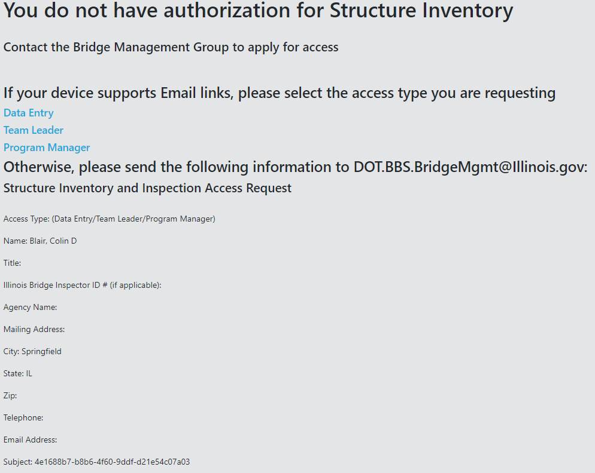

Open a Structure
When “opening”, or searching for a structure, there are a couple of ways this can be accomplished. It can be done by using the Open/Search field or through the BIS menu in the Assigned to Me section.
Open/Search Field
In the IHIS header, you can open/search for an inspection by entering the Structure Number for the structure in question in the Open/Search field. Under the ISIS option, you can see a historical list of inspections by choosing the Inspections section, then selecting the Inspection Type (ISIS > Inspection > Inspection Type).
- To search by Structure Number, enter the number of the structure in the Open field, then click the Search (magnifying glass) icon.
After the structure information is provided, both the ISIS & BIS data is loaded into the application (blue progress bar)
- Click the ISIS menu option, which reveals the ISIS sections (General, Inventory & Inspection)
- Click the Inspection menu option, which shows the different available Inspection Types:
Ex. Routine, Fracture Critical & Underwater

- Select an Inspection Type, which displays a historical list of inspections, as well as an option to create a “new” inspection
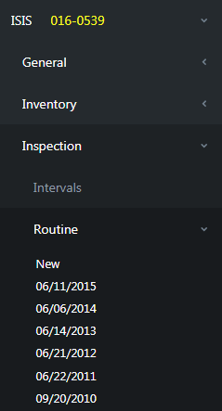
- Choose an inspection from the list to open the inspection in the main window of the application

Assigned To Me
In the left navigation list, you can find your directly assigned inspections in the Assigned To Me section of BIS. Under the BIS option, look for the assigned Structure Number in the list of available structures. Select a structure to see the Inspection Type available for the structure, as well as the status of any due/in progress or upcoming inspections (BIS > Assigned To Me > Structure Number > Inspection Type).
- To see the structures assigned directly to you, click the BIS menu option, which displays the next set of menu items
- Click the Assigned To Me option to view the list of your structures
- Look through the list, sorted by Structure Number, to find the specific structure in question
- Expand the structure to see your assigned inspections
- Select the Inspection Type to create a new inspection
  - If there is an inspection that is already started (“provisional”), then a new one will not be created, and the system will load the in-progress inspection
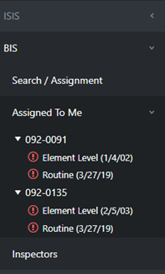
Note: An icon next to the Inspection type, shows the status of the inspection. The icons include are for Active/In Progress (yellow) & Overdue/Delinquent (red) inspections.
Assign a Structure
To assign a structure to a qualified Team Leader, a Program Manager can search for and assign one or multiple structures to an Inspector. This can be accomplished in the Assignment section of BIS, only by a user with the Program Manager role. From the BIS menu, select the Assignment option (BIS > Assignment).
Assign a structure
When assigning a structure to a Team Leader, you can search for the structure in the Search Criteria section, then assign it to an individual. You search by Inspection Date and by the Maintenance Source of the structure in question.
Optional search parameters include Assigned To, Inspection Route, Team Section and Team Sub-Section. The search parameters for Team Section and Team Sub-Section will return results if the number is found in either the On or Under data.
- To search by Inspection Date, enter the “From/To” dates of the inspection, then click Search.
- To filter by Structure Number, click the three stacked dots in the Structure # column of the Results section and pick Filter. Select “Is equal to” from the first dropdown list. Enter a Structure Number in the first open field, then click Filter.

Note: You must include the “dash” in the structure number (after the county code)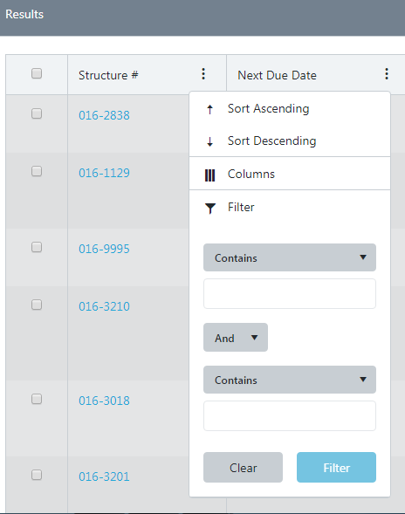

- Select the structure to assign by placing a checkmark in the box next to the Structure Number. To assign multiple structures, select the checkbox next to multiple Structure #’s.
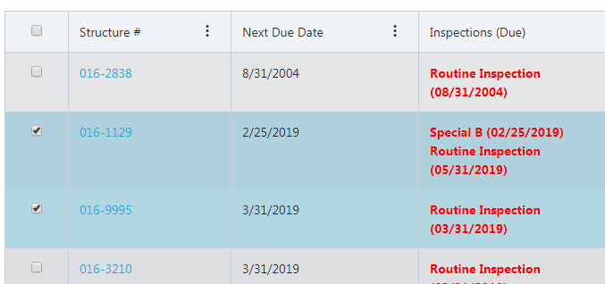

- Once the structure or structures are selected, click the right menu option (“hamburger” button) to assign
- On the Assign tab, click the “Assignment” dropdown menu to view the eligible Team Leaders
- Select the name of the Team Leader from the dropdown list
- Click the Save button
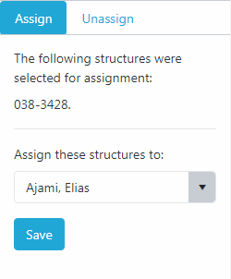
Unassign a structure
When unassigning a structure from a Team Leader, you can search for the structure in the Search Criteria section, then unassign it.
- Search for the structure the same as above, to assign the structure
- Select the structure to unassign by placing a checkmark in the box next to the Structure Number. To unassign multiple structures, select the checkbox next to multiple Structure #’s.
- Once the structure or structures are chosen, click the right menu option (“hamburger” button)

- On the Unassign tab, click the Save button to unassign the selected structures
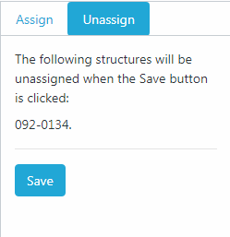

Search/Assignment
Search Criteria
When searching for a structure, whether it’s by the assigned Inspector’s Name, Inspection Date, or Maintenance Source, you can do so in the Structure Assignment section. From the BIS menu, select the Assignment option (BIS > Assignment).
In the Search Criteria section, you can search by Inspection Date, Inspector’s Name, or by the Maintenance Source of the structure in question.
- To search by Inspection Date, enter the “From/To” dates of the inspection, then click Search.
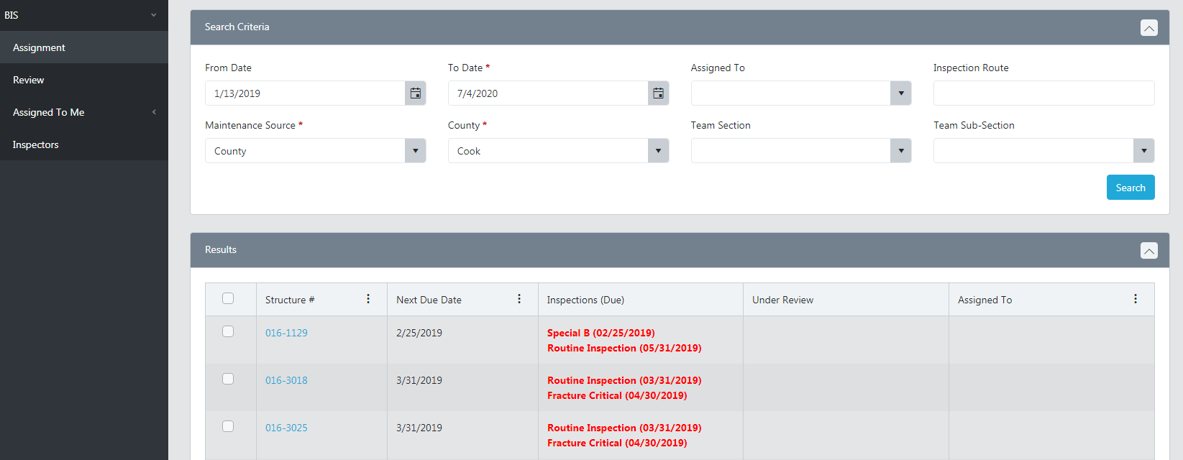
- To search by Maintenance Source, select the maintenance type, select the applicable county/district/municipality, then click Search.
Note - Maintenance Source filters what is in the drop down next to it. What you pick in the second drop down will then filter structures based on Maintenance Responsibility (21A and 21B) and Reporting Agency (22A).
- To search by Inspector’s Name, click the dropdown menu for “Assigned To”, select the name of the Inspector, then click Search.
Optional search parameters include Inspection Route, Team Section and Team Sub-Section. The search parameters for Team Section and Team Sub-Section will return results if the number is found in either the On or Under data.
Results
In the Results section, you can sort and filter the outcome of a structure search. Results include Structure Number, Next Due Date, Inspections Due, Under Review and Assigned To for the structure in question. There is also the option to hide/show certain columns.
- To filter by Structure Number, click the three stacked dots in the Structure # column of the Results section and pick Filter. Select “Is equal to” from the first dropdown list. Enter a Structure Number in the first open field, then click Filter.
Note: You must include the “dash” in the structure number (after the county code)

- To filter by Next Due Date, click the three stacked dots in the Next Due Date column of the Results section and pick Filter. Select “Is after or equal to” from the first dropdown list. Enter a date in the first open field (or use the date picker), then click Filter.

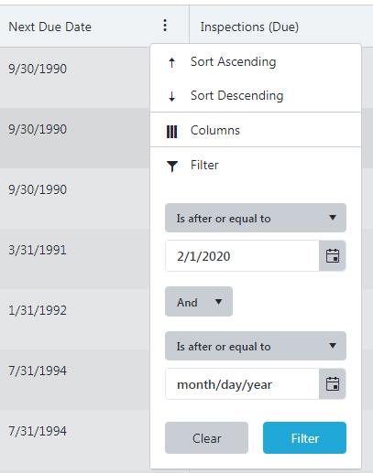
- To filter by Assigned To, click the three stacked dots in the Assigned To column. Select “Is equal to” or “Contains” from the first dropdown list. Enter a name (or partial) in the first open field, then click Filter.

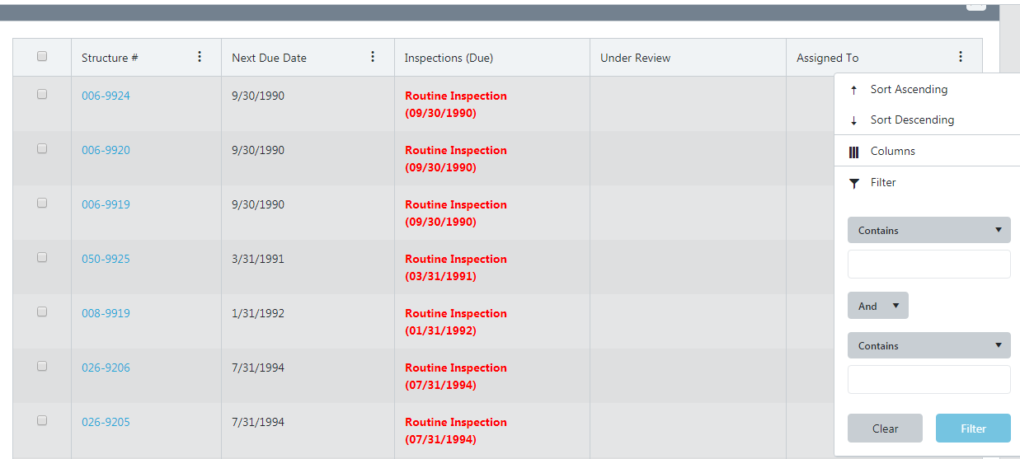

Note: Each user can see all structures within their assigned jurisdiction. State Inspectors can only assign and edit structures from within their district. Local inspectors can only assign and edit structures within their maintenance responsibility, unless shared with the state. Those structures are assigned at the State level. Central users can see, edit and assign all structures.

 | State Users  (incl. Central Office & 9 Districts) | Local Users (Non- State employees)  (incl. County, Municipality & Township)
Can View | All structures | Structures within their jurisdiction
Can Edit Inspections | State structure inspections within their jurisdiction | Structure inspections within their jurisdiction, for which they are responsible

Create a New Inspection
Once an Inspector is qualified, you will want them to now enter inspections into the system. This will allow them to create, submit and request approval for any inspection electronically.
New inspections can be created in the ISIS section, under the Inspection section (ISIS > Inspection > Inspection Type). To begin, either Open/Search for the specific structure, or navigate to structure in the Assigned to Me section, under the BIS menu. Once you have found the structure, you can start a new inspection. When the inspection is loaded, the IHIS inventory “green bar” is displayed, with inventory specific to the structure. 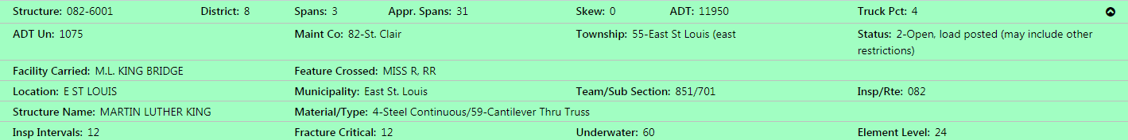
When creating a new inspection, there are a couple of ways this can be accomplished. It can be done by using the “New” option from the expanded left-side navigation tree’.
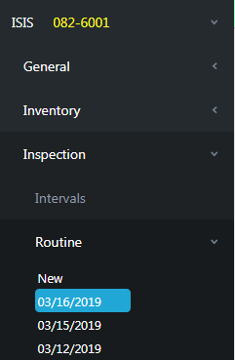
This can also be accomplished by using the “New” button, underneath the right-side navigation (“hamburger” button) of a selected structure.
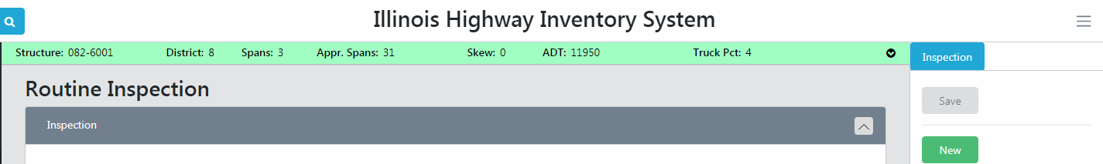
Each Inspection Type has common required fields, which reside in the Inspection section of each Inspection Type. Those common required fields are Inspection Date, Temperature, Agency Program Manager and Team Leader.
Each Inspection Type also has the comments from the previous inspections automatically populated in the Remarks section. Special Inspections requires the New inspection to be saved before the previous comments are displayed.

Routine Inspection
To create a Routine Inspection, complete the following required information:
- Inspection Date (this date cannot be greater than the current date)
- Temperature (either type or scroll the list to find a number)
- Agency Program Manager (must be an active, “qualified” Inspector to be presented in this list)
- Team Leader (same as above)
Note: Inspector, Consultant Program Manager and Delinquency Reason fields are not mandatory to be completed. You must complete the Delinquency Reason field if the inspection is past due.
Most of the unavailable data or sections are pulled directly from IHIS, so it cannot be edited in BIS. Some of these include the structure’s Routine Interval, Interval Date, Resources section, etc. Comments from previous inspections are also displayed in the Remarks section.

Once the mandatory fields are filled out, you can save a partial inspection, and complete/submit it later. Whenever you come back to an “in-progress” inspection (provisional), the application automatically grabs the saved inspection and loads it onscreen. Any structure can have only one new or active inspection at a time.
In the Appraisals section, you can fill out all the condition ratings of the structure, as well as leave the required comments for your findings.
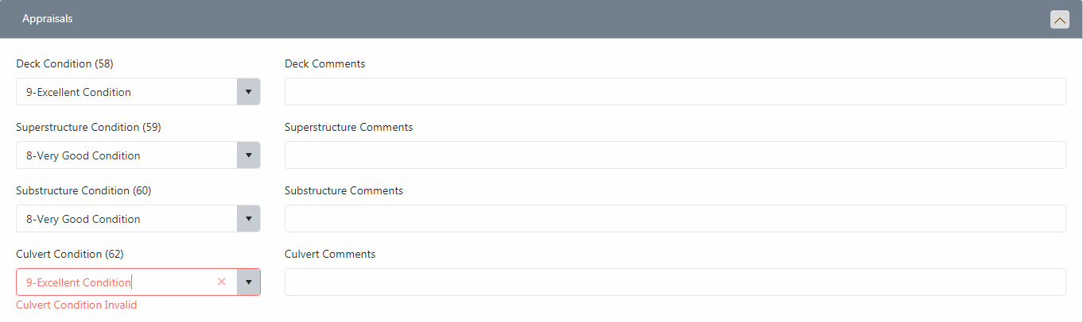
Here’s an example of one of the possible validation error messages:
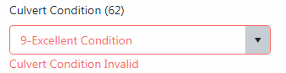
In the next few sections, fill out the Routine inspection with the necessary information:
- Railings
- Deck Assessments
- Paint
- Utilities
- Postings
- Remarks
Once you have completed both the required and any optional information for the structure, you can submit the Inspection for approval.

Fracture Critical Inspection
Like Routine Inspections, each Fracture Critical Inspection needs to have the common required fields completed, which reside in the Inspection section of each Inspection Type. Those common required fields are Inspection Date, Temperature, Agency Program Manager and Team Leader.
To create a Fracture Critical Inspection, complete the following required information:
- Inspection Date (this date cannot be greater than the current date)
- Temperature (either type or scroll the list to find a number)
- Agency Program Manager (must be an active, “qualified” Inspector to be presented in this list)
- Team Leader (same as above)
Note: Consultant Program Manager, Inspector & Delinquency Reason fields are not mandatory to be completed. You must complete the Delinquency Reason field if the inspection is past due.
The unavailable data or sections are pulled directly from IHIS, so it cannot be edited in BIS. Some of these include the structure’s Routine Interval, Interval Date, Resources section, etc.
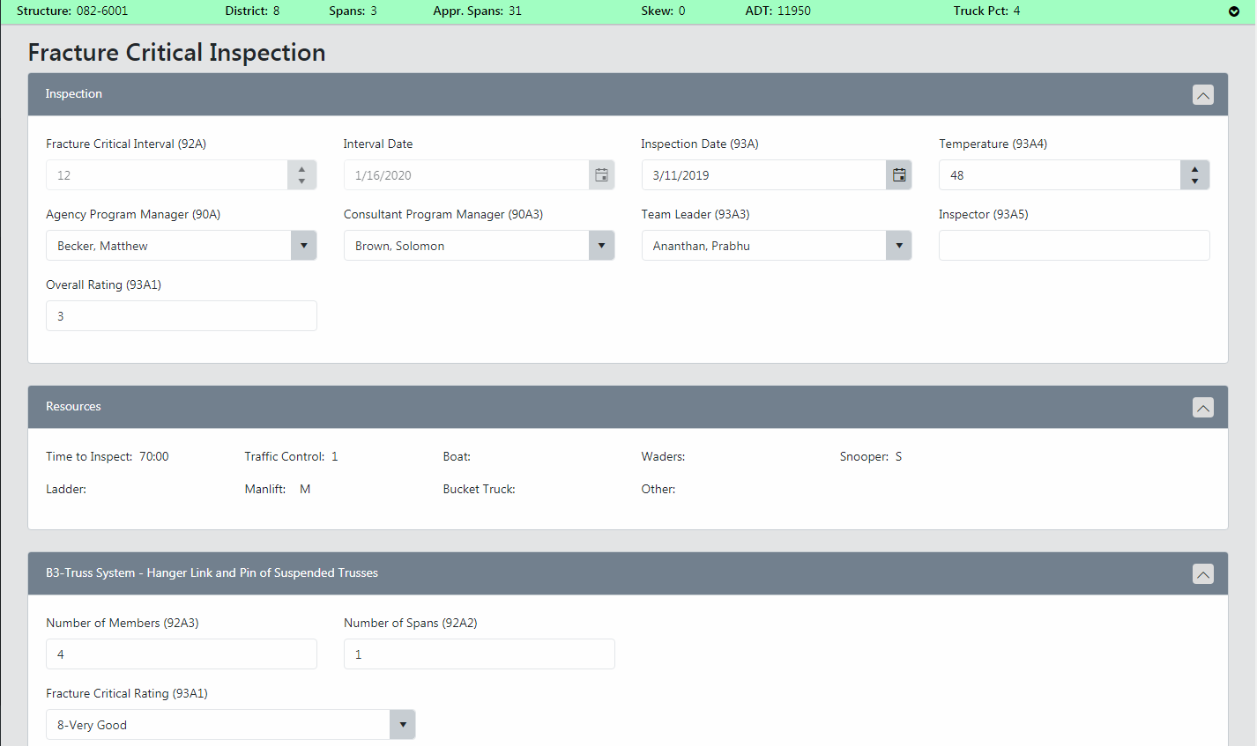
In the next few sections, fill out the Fracture Critical inspection with the necessary information. Here’s a sample of the Fracture Critical Types:
- B3-Truss System - Hanger Link and Pin of Suspended Trusses
- B4-Truss System - Single Element Tension Members
- B5-Truss System - Simple Span Riveted or Bolted Tension Members
- B6-Continuous Truss System - Welded, Riveted or Bolted Tension Members
- E1-Framed Steel Substructures - Welded or Rolled Pier Cap
- E2-Framed Steel Substructures - Riveted or Bolted Pier Cap
- E3-Framed Steel Substructures - Welded or Rolled Pier Column
- X2-Floorbeams Supporting Other Steel Members or Spacing > 15'
- X3-Cross Frames or Transfer Beams
There are 30 types in total; for the full list, refer to item 92A1 in the SIP manual.
Once you have completed both the required and necessary information for the structure, you can submit the Inspection for approval.

Underwater Inspection
Like other Inspections, each Underwater Inspection needs to have the common required fields completed, which reside in the Inspection section of each Inspection Type. Those common required fields are Inspection Date, Temperature, Agency Program Manager and Team Leader.
To create a Fracture Critical Inspection, complete the following required information:
- Inspection Date (this date cannot be greater than the current date)
- Temperature (either type or scroll the list to find a number)
- Agency Program Manager (must be an active, “qualified” Inspector to be presented in this list)
- Team Leader (same as above)
Note: Consultant Program Manager, Inspector & Delinquency Reason fields are not mandatory to be completed. You must complete the Delinquency Reason field, if the inspection is past due.
The unavailable data or sections are pulled directly from IHIS, so it cannot be edited in BIS. Some of these include the structure’s Routine Interval, Interval Date, Resources section, etc. Comments from previous inspections are also displayed in the Remarks section.
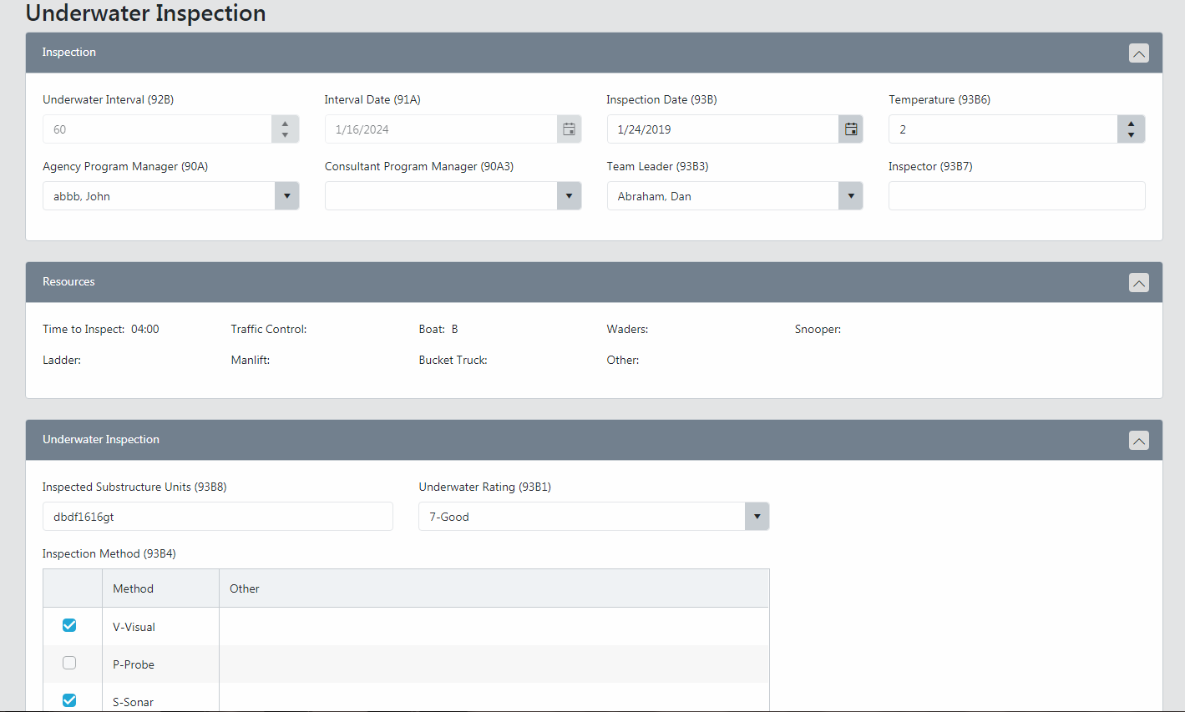
In the next section, fill out the Underwater Inspection with the necessary information.
Once you have completed both the required and necessary information for the structure, you can submit the Inspection for approval.

Special Inspection
Like other Inspections, each Special Inspection needs to have the common required fields completed, which reside in the Inspection section of each Inspection Type. Those common required fields are Special Inspection Inventory, Inspection Date, Temperature and Agency Program Manager.
To create a Special Inspection, complete the following required information:
- Special Inspection Inventory (pick the inventory type)
- Inspection Date (this date cannot be greater than the current date)
- Temperature (either type or scroll the list to find a number)
- Agency Program Manager (must be an active, “qualified” Inspector to be presented in this list)
Note: Consultant Program Manager, Team Leader, Inspector & Delinquency Reason fields are not mandatory to be completed. You must complete the Delinquency Reason field if the inspection is past due.
The unavailable data or sections are pulled directly from IHIS, so it cannot be edited in BIS. Some of these include the Interval Date, Resources section, etc. Comments from previous inspections are also displayed in the Remarks section once the New Special Inspection has been saved.
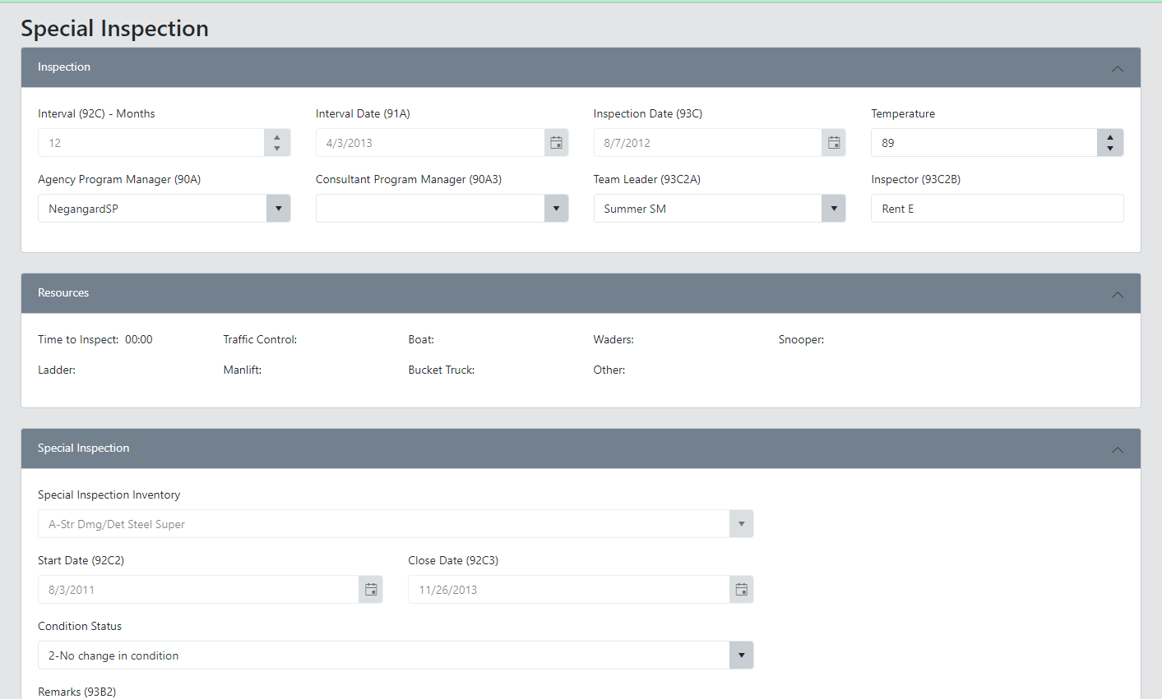
In the next section, fill out the Special Inspection with the necessary information.
Once you have completed both the required and necessary information for the structure, you can submit the Inspection for approval.

Element Level Inspection
Like other Inspections, each Element Level Inspection needs to have the common required fields completed, which reside in the Inspection section of each Inspection Type. Those common required fields are Inspection Date, Temperature, Agency Program Manager and Consultant Program Manager.
To create an Element Level Inspection, complete the following required information:
- Inspection Date (this date cannot be greater than the current date)
- Temperature (either type or scroll the list to find a number)
- Agency Program Manager (must be an active, “qualified” Inspector to be presented in this list)
- Team Leader (same as above)
Note: Consultant Program Manager, Inspector & Delinquency Reason fields are not mandatory to be completed. You must complete the Delinquency Reason field if the inspection is past due.
Note: Remove Legacy Elements button will remove all the existing elements from that Inspection.
The unavailable data or sections are pulled directly from IHIS, so it cannot be edited in BIS. Some of these include the structure’s Routine Interval, Interval Date, Resources section, etc. Comments from previous inspections are also displayed in the Remarks section.
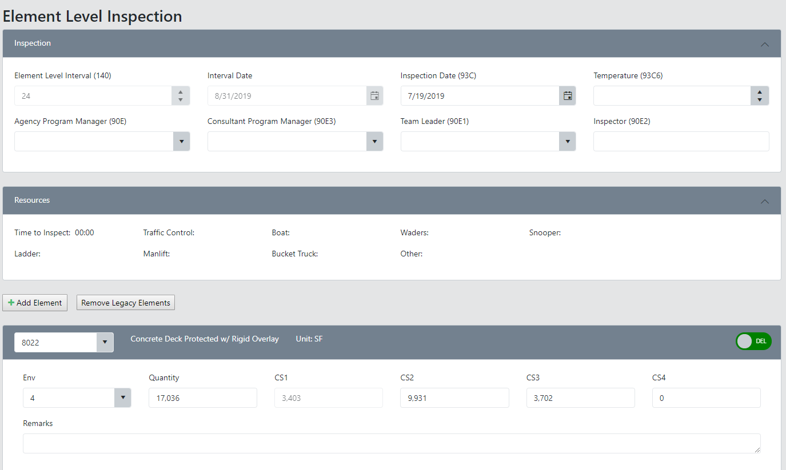

Add Element
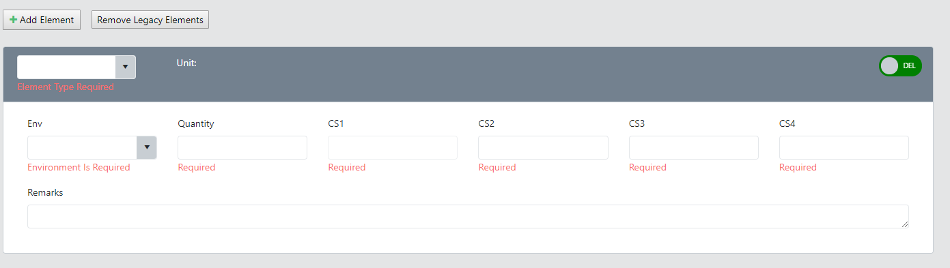
Click Add Element button and enter required fields to add a new element to the structure. You will need to click Save button to add the new element.
Delete Element
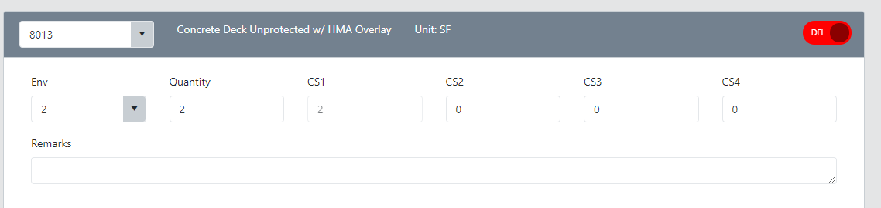
You can delete one or many elements by selecting delete button. You will need to click save to delete the element.
Fill out the Element Level Inspection with the necessary information. Once you have completed both the required and necessary information for the structure, you can submit the Inspection for approval.
Submit an Inspection
Once you have completed all the mandatory & necessary information regarding a structure, you can submit the inspection for approval. This sends it to the designated Program Manager, who will review and approve the work. During the submission process, any needed validation is completed for the inspection. If the specific criteria are not met, either the Inspector or Program Manager can make edits before approval. Once approved, no edits can be made to the inspection.
To submit an Inspection for Approval:
- Complete all the mandatory and any optional information regarding a structure. Ensure any needed validations are corrected.
- Click the right-side navigation (hamburger button) to display the Inspection tab
- Click the Submit button
When the inspection is submitted, the associated Program Manager will be notified that there is a provisional inspection to approve.

Approve an Inspection
Anyone with Program Manager permissions can approve an inspection. Each Program Manager will see a list of provisional inspections that they have to approve. All Program Managers can see all inspections but can only approve those within their jurisdiction. To see the Approve button, you must be logged in as a Program Manager.
To Approve an inspection:
- Search the Structure #
- Select an inspection to approve
- Click the right-side navigation (hamburger button) to display the Inspection tab
- Click the Approve button

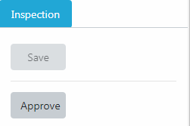
During the Approval process, either the Inspector or Program Manager can make edits before approval. Once approved, no edits can be made to the inspection.
After approval (or at any time during the submission process), you can see all the create, submit, approval and modification actions in the Audit Log. The Audit Log tracks and logs all actions performed on the structure, including a date & time stamp for audit purposes.
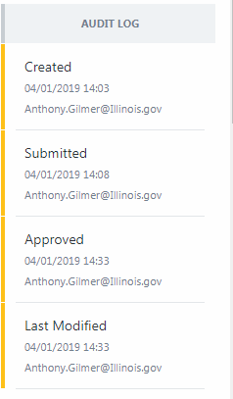

Create a Review List
Program Managers can create a Review List of inspections to review and approve. From the BIS menu, select the Review option (BIS > Assignment).
In the Search Criteria section, search by the Maintenance Source of the structure in question.
Optional search parameters include Inspection Route, Team Section and Team Sub-Section. The search parameters for Team Section and Team Sub-Section will return results if the number is found in either the On or Under data.
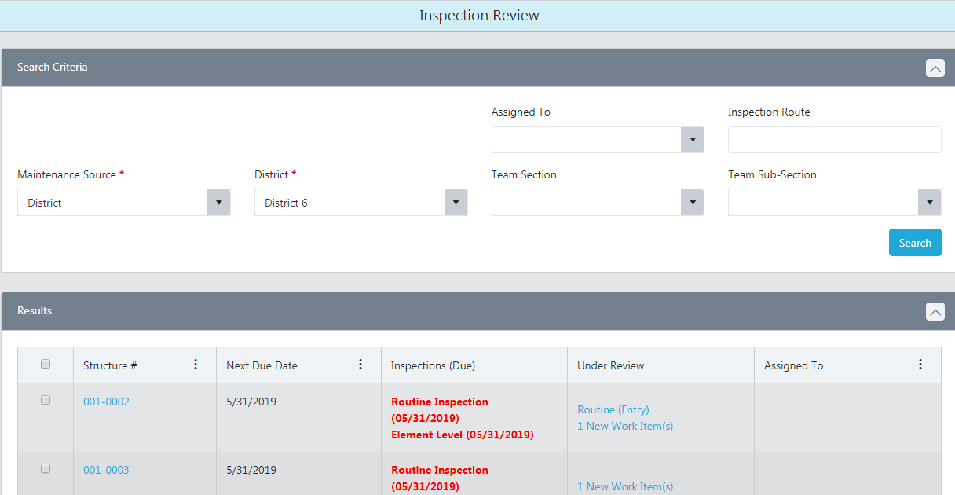
- To search by Maintenance Source, select the maintenance type, select the applicable county/district/municipality, then click Search.
Note - Maintenance Source filters what is in the drop down next to it. What you pick in the second drop down will then filter structures based on Maintenance Responsibility (21A and 21B) and Reporting Agency (22A).
- To search by Inspector’s Name, click the dropdown menu for “Assigned To”, select the name of the Inspector, then click Search.
- Once the search results are displayed, click the top right menu option (“hamburger” button)
- Mark the checkbox in the result grid of the inspections and work items to review. As items are checked, the counter in the review list changes:

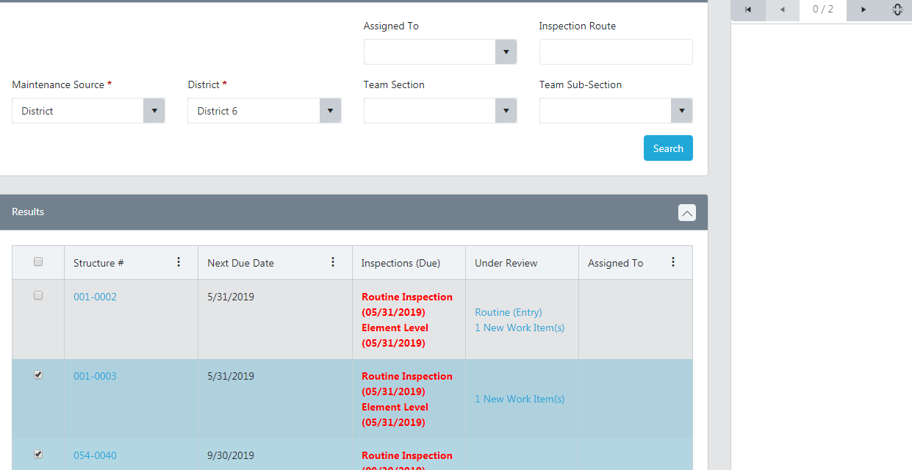

- To begin reviewing inspections and work items in the queue, click the forward arrow. The first item is loaded in the window for review and approval.
- Navigate through the review list by clicking the forward and back arrows. Items can be approved as reviewed or held in the queue until a later date.
While working in a Review list, if you navigate to another screen, you may return to the queued items by clicking on the ‘Resume’ button (that replaces the numbering of the queued items):
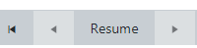

If the ‘Unassign’ option is enabled, and no other inspection for that structure is due within 90 days, then the inspector is automatically unassigned from that structure once the inspection is approved.

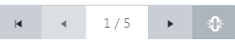

Create a Work Item
New work items can be created in the ISIS section, under the Work section (ISIS > Work). To begin, either Open/Search for the specific structure. Once you have found the structure, you can create a new work item by clicking the “Add” button. Work item code and Description are mandatory fields which must be entered.
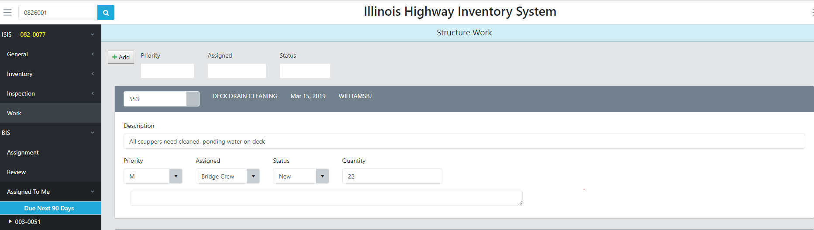
Users may choose to update Priority, Assigned, Status and Quantity fields at any time.

Email a work item
Users can email details about a work item through BIS.
- Load a structure in BIS
- Go to ISIS > Work to display the work items associated with the structure
- Click on the email icon on the right side of the work item header bar
- A draft email is generated containing the following details:
- Description
- Repair code/Type and Description - e.g. 752 - slopewall repair
- Quantity and units
- Comments
- Structure Number
- Facility Carried
- Feature Crossed
- Location
- GPS coordinates (Latitude & Longitude)
- Google Maps URL

- Enter the email recipients, edit the email as desired (edit email body, add attachment, etc.) then send.

Print an Inspection
New inspections can be printed in the ISIS section, under the Inspection section (ISIS > Inspection > Inspection Type). To begin, either Open/Search for the specific structure, or navigate to structure in the Assigned to Me section, under the BIS menu. Once you have found the structure, you can navigate to the “New” Inspection which you want to print. Expand the right side menu option (“hamburger” button) if not already expanded.
Click on the Print New button to print a new inspection form.
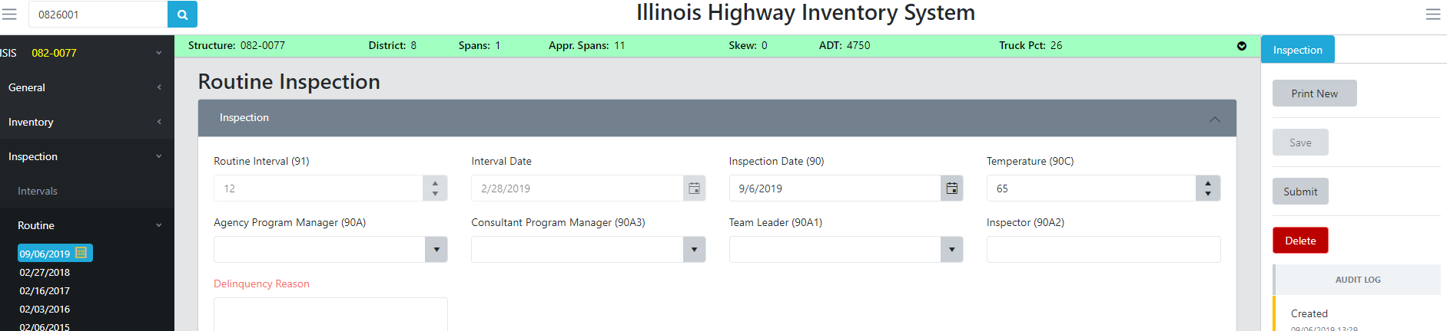

Historical approved inspections can be printed in the ISIS section, under the Inspection section (ISIS > Inspection > Inspection Type). To begin, either Open/Search for the specific structure. Once you have found the structure, select the Inspection which you want to print. Expand the right side menu option (“hamburger” button) if not already expanded.
Click on the Print button to print the inspection form.
Optionally, click the Print with History button to generate a printout of the inspection that also includes historical remarks.
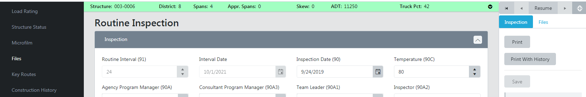

Upload a file

Note – the first time a user navigates to the General > Files page, a legal disclaimer is displayed. The user must read the disclaimer and click Accept to proceed with file management. After accepting, the Legal Disclaimer text will default to a collapsed state each time the user accesses the Files page. To view the text at any time, expand the Legal Disclaimer using the down arrow in the title bar.

Structure Level
Users with file upload/linking permissions can upload a file at the structure level and then that same file can be associated with either an inspection or a work item. This eliminates the need to have the same file uploaded multiple times and associated to the different components.
- Load a structure in BIS
- Go to ISIS > General > Files
- A grid appears listing all files related to the structure either uploaded via the structure files component, with a work item or with an inspection
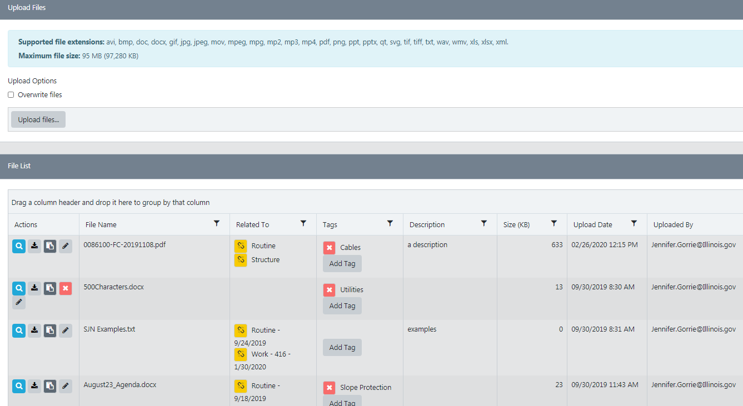
- To upload a file, click the ‘Upload Files’ button to navigate to the file to upload. Use the file explorer to select the file to upload.
- Once uploaded, a success message appears and the file is listed in the recent history section.
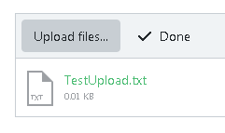
Files that are linked to more than one component (structure, inspection, work item) are grouped in the ‘Related To’ column.
The delete icon will only appear for a row if the file is linked to only one component.
To unlink a file, click the yellow link icon.
To enter a description for the file, click the pencil icon. The description textbox for that file becomes editable and the pencil icon changes to the save icon. After entering the description text, click the save icon to save the description. Description text is limited to 100 characters.
To add a tag for the file, click the Add Tag button to choose from a list of predetermined tags. Click on the tag text to add the tag to the file. To remove the tag, click the red box
Duplicates of the same file are not allowed. If a file with the same file name has already been uploaded, a subsequent file cannot be uploaded. An error message is displayed if the file has already been uploaded.
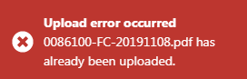

If a file with the same file name needs to be uploaded to replace the existing file, click the ‘Overwrite files’ checkbox.
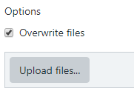

Inspection Level
Users with file upload/linking permissions can either upload a new file that is not already associated with the structure or a work item, or to associate an existing file to an inspection.
- Load a structure in BIS
- Go to ISIS > Inspection > target inspection type
- Click the top right menu option (“hamburger” button) if not already expanded.
- Click the Files tab

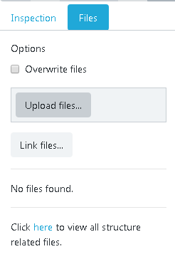
Use the ‘Upload Files’ button to upload a file that is not already uploaded to the structure at any level (structure, work item, inspection).
Use the ‘Link Files’ button to associate file(s) already uploaded to the structure to also be referenced at the Inspection level. A listing of currently uploaded files is displayed. Once linked, the files are not duplicated; the same file is simply linked to both the inspection and the structure.
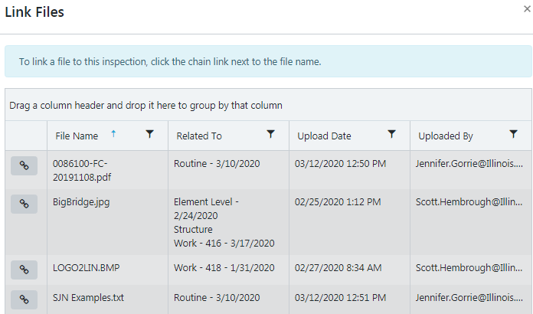

The uploaded or linked files then appear in a list for the inspection:
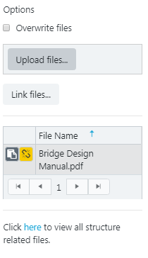
Click on the here link to view all structure related files. A grid appears listing all files related to the structure either uploaded via the structure files component, with a work item or with an inspection.
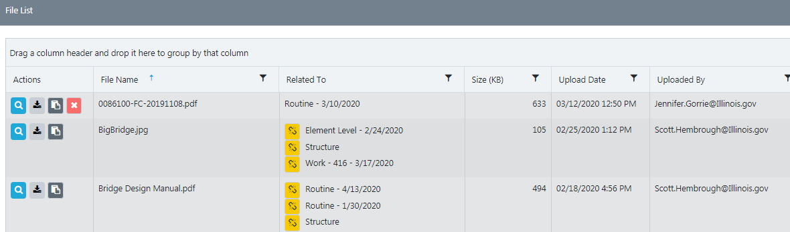

Work Items Level
Users with file upload/linking permissions can either upload a new file that is not already associated with the structure or an inspection, or to associate an existing file to a work item.
- Load a structure in BIS
- Go to ISIS > Work
- Click the top right menu option (“hamburger” button)
- Click the Files tab
- If a work item is new and has not yet been saved, or if an existing work item has not been selected, the following message will appear:

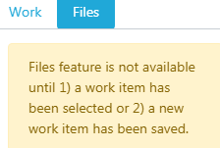
- Save an in-progress work item or click on an existing work item to select it. The existing work item will have a blue header to indicate it is selected.
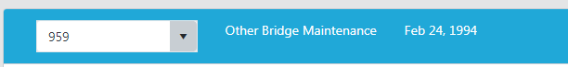
- The work item number and date appear, as well as a list of any files already associated and a link to view all structure related files.
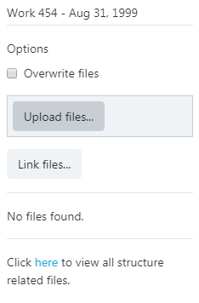
Use the ‘Upload Files’ button to upload a file that is not already uploaded to the structure at any level (structure, work item, inspection).
Use the ‘Link Files’ button to associate file(s) already uploaded to the structure to also be referenced at the work item level. A listing of currently uploaded files is displayed. Once linked, the files are not duplicated; the same file is simply linked to both the work item and the structure.

The uploaded or linked files then appear in a list for the inspection:

Click on the here link to view all structure related files. A grid appears listing all files related to the structure either uploaded via the structure files component, with a work item or with an inspection.

Training Class Level

Users with file upload permissions can upload a file to a Training Class.
- BIS > Training
- Click on a Class Name to open the details about that class.
- Click the top right menu option (“hamburger” button) if not already expanded.
- Click the Files tab
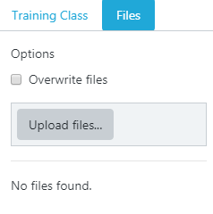
- To upload a file, click the ‘Upload Files’ button to navigate to the file to upload. Use the file explorer to select the file to upload.

Once uploaded, the file appears in the list of uploaded files.
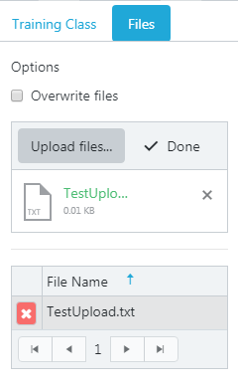

Click on the delete icon to remove the file from the training class

If a file with the same file name needs to be uploaded to replace the existing file, click the ‘Overwrite files’ checkbox then use the ‘Upload files’ button.

View and download files

Note – the first time a user navigates to the General > Files page, a legal disclaimer is displayed. The user must read the disclaimer and click Accept to proceed with file management. After accepting, the Legal Disclaimer text will default to a collapsed state each time the user accesses the Files page. To view the text at any time, expand the Legal Disclaimer using the down arrow in the title bar.
Users with file view permissions can view picture files directly in the application or download the picture. Non-picture files can be downloaded to the user’s computer and viewed as a local file.
- Load a structure in BIS
- Go to ISIS > General > Files
- A grid appears listing all files related to the structure either uploaded via the structure files component, with a work item or with an inspection
- Click on the view icon to have the file open in a new viewer window. Only picture files can be viewed directly within the BIS application at this time. If the file is not a picture, the file will automatically be downloaded to the user’s computer for viewing.
- Click on the download icon to download any file.
- Click on the copy icon to copy the URL link for a file in order to paste into an email, word document, etc.
Files that are linked to more than one component (structure, inspection, work item) are grouped in the ‘Related To’ column.
The delete icon will only appear for a row if the file is linked to only one component.
To unlink a file, click the yellow link icon.

General Notes

Required Fields

When editing within the BIS application, if a required data field is empty, a red outline appears to indicate that data needs to be entered.
An example is the Inspector details page. If the save button is disabled because not all required fields are populated, the user may not know immediately what data needs to be entered. The user may need to expand sections to see empty required fields. In the example below, Phone number is currently blank but is a required field to save the Inspector information.

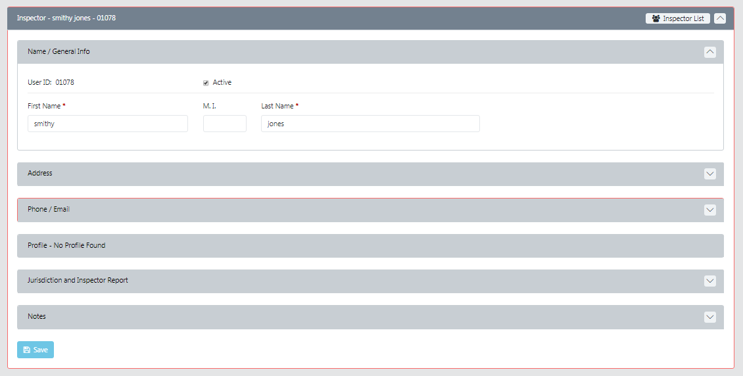

Another example is shown below for Element inspections. A red outline indicates a section that needs user attention.

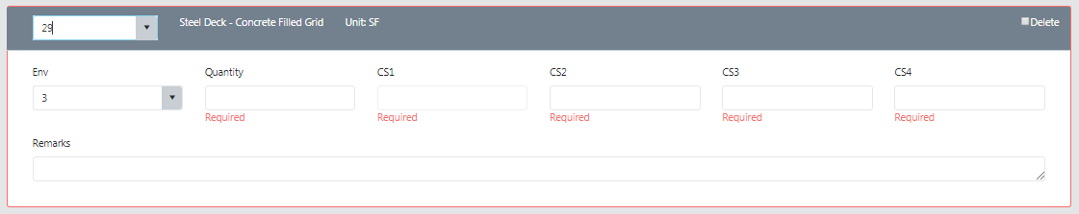

New: Data Entry

Each inspection type has an option to create and save a new ‘Data Entry’ inspection. Users with the ‘Local District Liaison’ role will only have the new ‘Data Entry’ option, not the ‘New’ option.

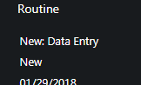

This process for users to create a new inspection that will not be submitted/approved in the same manner as a regular inspection.
Ideally the PM or TL that completed the inspection would be entering the inspection data in BIS. However, there may be support staff entering inspection information. Rather than using the current save/submit button, these users require a distinct approach that will track the actual user entering the inspection information (who is not necessarily the PM or TL).

Uses will also continue have the option to create a new inspection by clicking the new button in the expanded right menu (hamburger button) for each inspection.
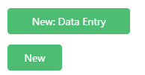

Allow Pop Ups

In order to use the BIS application, it is required that your browser allows Pop Ups.
If Pop Ups are currently blocked, you will see an icon in the address bar
Click on the icon to select ‘Allow’ for Pop Ups on the BIS website.

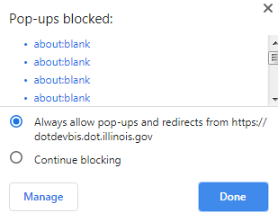

To turn pop-ups on in Chrome settings:
- At the top right, click More. Settings.
- Under "Privacy and security," click Site settings.
- Click Pop-ups and redirects.
- At the top, turn the setting to Allowed.

Additional Table Functions

In addition to the sort and filter option on tables in the BIS system, users can customize the tables and results grids even further.
Turn on and off certain columns:
- Click on the 3 stacked dots in the column header to expand the custom table options.
- Click on ‘Columns’ to display the columns that are available to be visible and hidden.
- Check/uncheck individual columns in order to hide/show them in the table.

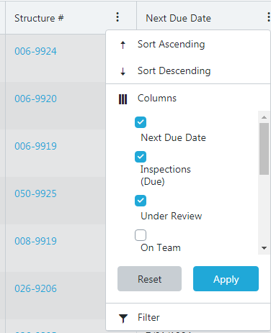

Group by columns:
If a table or search results grid displays the ‘Drag a column header and drop it here to group by that column’ message, click on a column header and, holding down the left mouse button, drag it to the message area. Multiple columns can be used to group the results.

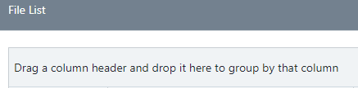

The items are then grouped by the column(s) selected.
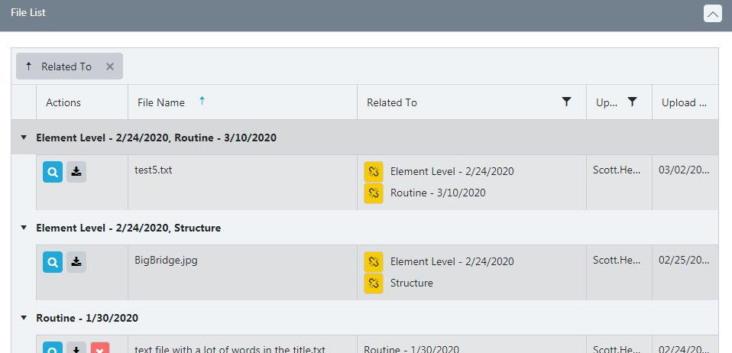

Some grids are designed differently and rather than the stacked dots, a column may have an arrow to indicate that the column can be sorted on. The direction of the arrowhead indicates if the column is currently sorted in ascending or descending order.
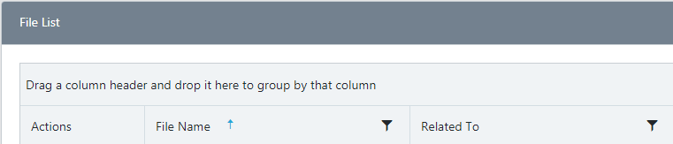

Other columns will have a filter icon that looks like a funnel. Click on the filter icon to display filter options. The filter can be used to match text, find within a date range or a specific date or find null/empty fields.
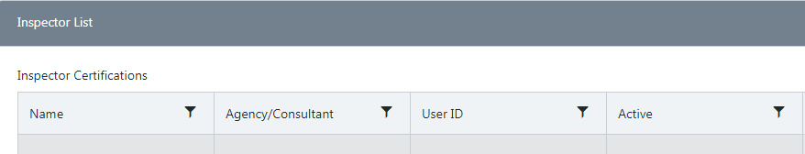
If a filter is currently applied to a column, the filter icon will change:
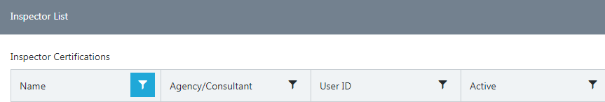

Inspection Approval Messages

Some of the BIS data entry business rules reference data in other inspections. As such, inspections can be submitted but the cross validations will need to be confirmed/acknowledged during inspection approval. Messages will be displayed at the top of the inspection screen after the inspection has been submitted. Warnings will be colored yellow while errors are colored red. An inspection may be approved with warnings but any displayed errors need to be fixed before the inspection can be approved.

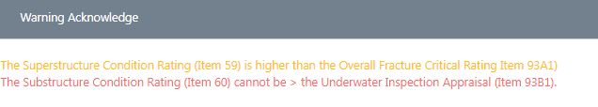
Once all errors have been handled, warnings will still display and an ‘Acknowledge’ button will appear. Approvers must confirm that they acknowledge the warnings exist and the inspection is ready for approval even with the warnings. The Approve button will be hidden until the approver clicks the acknowledge button.
