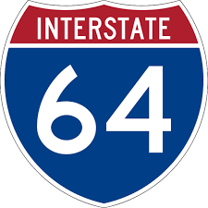
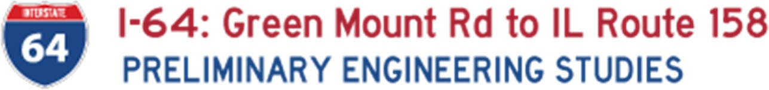
I-64: Green Mount Road to IL Route 158 PRELIMINARY ENGINEERING STUDIES
I-64: Green Mount Rd to IL Route 158
PRELIMINARY ENGINEERING STUDIES
Virtual Public Meeting Nov. 9

PUBLIC COMMENT FORM

The project team invites you to share your comments and views regarding the I-64 Preliminary Engineering Studies from Green Mount Road to IL Route 158. In the comment area below provide any concerns, observations and/or thoughts you have about the proposed improvement. Your input will be directed to the project team for evaluation and consideration in proceeding with this engineering study. You may either scan and email the form to matthew.meyer@illinois.gov or mail it to the address provided below. Comments can be submitted until Nov. 23.

Mr. Keith Roberts, P.E. Acting Region Five Engineer
Illinois Department of Transportation 1102 Eastport Plaza Drive Collinsville, IL 62234-6198 Attention: Matthew Meyer

- Comments:

- I am a (check all that apply):
Resident.
Business Owner.
Commuter.
Tell Us About You!
Name:
Address:
City/State/Zip code:

Other .
Telephone:
Email:

- How did you find out about this Virtual Public Meeting? Please check all that apply.

Email
Local Media Coverage
Word of Mouth
Social Media
Public advertisement (i.e. yard sign)
Other

THANK YOU!
Please indicate your preferred method of communication:
Mail Email

