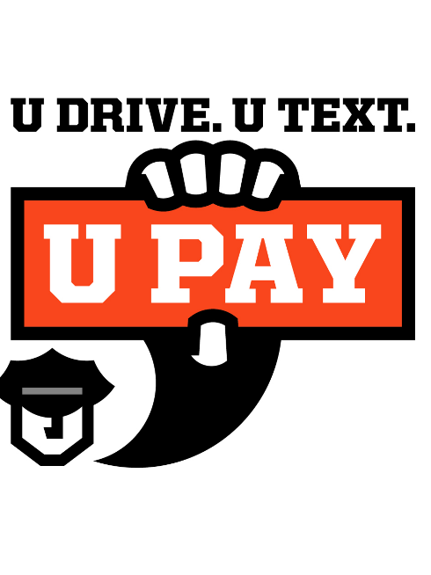
(Department/City Letterhead)

NEWS

FOR IMMEDIATE RELEASE
Date

For Information, Contact:
Name
Phone Number
Email

The (Your Department's Name) announces distracted driving
enforcement results for April 2026

(Your City, Ill.) – (Your department's name) announced it issued (#) citations for distracted driving violations and (list other citation/DUI #s) during April's Distracted Driving Awareness Month enforcement campaign.

"Distracted driving remains a serious problem in (city/county), and one moment of inattention can change lives forever," said (your department’s spokesperson). "High-visibility enforcement is one way we remind drivers that safe driving requires their full attention. April may be over, but our message is not. (Your department) will continue enforcing distracted driving laws and urging motorists to put the phone away whenever they get behind the wheel."

(Your department) joined forces with the Illinois State Police, local law enforcement and highway safety partners for this enforcement effort.

The Illinois distracted driving campaign was funded with federal traffic safety funds administered by the Illinois Department of Transportation.

###

