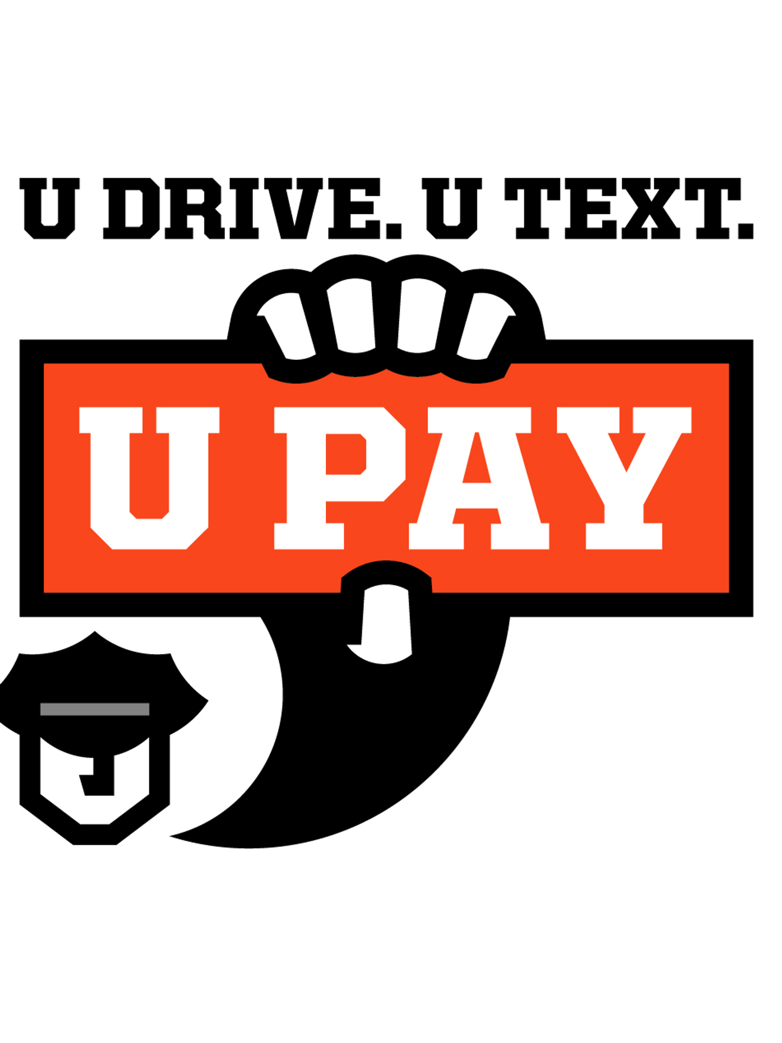
(Department/City Letterhead)

NEWS

FOR IMMEDIATE RELEASE
(Date)

For Information, Contact:
Name
Phone Number
Email

Put the phone away or pay

Law enforcement steps up April distracted driving enforcement

(Your City, Ill.) – In recognition of Distracted Driving Awareness Month, the (Your Department) is partnering with the Illinois Department of Transportation, the Illinois State Police and local law enforcement agencies across Illinois to step up enforcement efforts throughout April. Motorists can expect increased patrols looking for texting, social media use, video viewing and other distracted driving violations.

"Distracted driving puts everyone at risk, and even a quick glance at a phone can have devastating consequences," said (Your department's spokesperson). "During April, officers will be looking for distracted driving violations and reminding motorists to put the phone away and focus on the road."

If you need to send a message, check directions or return a call, pull over and park safely first. Whatever the solution, do not drive distracted.

In Illinois, manually using an electronic communication device while driving is not only dangerous, but also illegal. Put the phone away or pay.

The Illinois distracted driving campaign is funded with federal traffic safety funds administered by the Illinois Department of Transportation.

###

