**(Department/City Letterhead)**

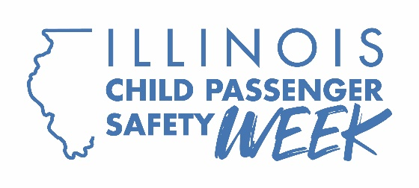

FOR IMMEDIATE RELEASE: **[Insert Date]**

CONTACT: **[Name, Phone Number, Email Address]**

**[Local Community/Organization] offers free car seat checks on Seat Check Saturday, Sept. 27**

[CITY] – As part of Child Passenger Safety Week, [Organization] today announced they will provide parents and caregivers free instruction on properly installing and using the correct car seats for their children on Seat Check Saturday, Sept. 27.

“Most parents believe they’re protecting their kids, but nearly half of car seats are either the wrong type for the child’s age and size or are installed incorrectly,” said [Spokesperson]. “This significantly increases the risk of injury in a crash. A simple but crucial step is to double-check their car seats to ensure safety.”

Child Passenger Safety Technicians will be offering free car seat safety checks starting at [time] at [location]. These experts will assist parents and caregivers in identifying the right seats for their children and demonstrate correct installation and use.

There is a right car seat for every age and developmental stage, from infants to teens. Whether it’s a rear-facing or forward-facing car seat, booster seat, or seatbelt, certified Child Passenger Safety Technicians can provide peace of mind by confirming the appropriate seat and demonstrating the correct installation. Children should remain in each type of seat until they exceed the height or weight limits specified by the car seat manufacturer, and all children under 13 should ride in the back seat.

Parents and caregivers unable to attend Saturday’s event can find local certified technicians by visiting [Buckle Up Illinois](https://idot.illinois.gov/transportation-system/transportation-safety/roadway-safety/education/traffic-safety-campaigns/buckle-up-illinois.html). The website allows users to filter by Spanish-speaking technicians, virtual appointments, and local Child Passenger Safety Week events. Additional resources, including research-based recommendations and car seat comparisons, are also available.

Parents are encouraged to register their car seats with manufacturers to receive notifications about recalls.

###