**(Department/City Letterhead)**

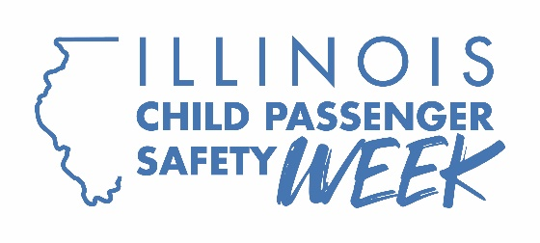

FOR IMMEDIATE RELEASE: **[Insert Date]**

CONTACT: **[Name, Phone Number, Email Address]**

**[Organization or Location]’s Seat Check Saturday event helped protect [XX] child passengers**

[CITY] – Every September, the Illinois Department of Transportation partners with local communities to observe Child Passenger Safety Week, including Seat Check Saturday. [Organization]’s car seat check event on Saturday in [location] was a success, with Certified Child Passenger Safety Technicians inspecting [XX] car seats.

“One of the simplest ways to protect child passengers is to make sure they’re in the right seats and that the seats are installed correctly,” [Spokesperson] said. “We were thrilled to see parents and caregivers come out and take some time to ensure their children are correctly buckled into the right seat. Not only does it give them peace of mind, but it could also mean the difference between life and death in a crash.”

During the event, Certified Passenger Safety Technicians helped parents and caregivers ensure their children were in the right seats for their age and size, and that their car seats were installed and used correctly. Parents at the event were also encouraged to register their car seats with the manufacturers to be notified of recalls.

The free event was part of Child Passenger Safety Week, which ran from Sept. 21-27.

Parents and caregivers don’t have to wait for the next Seat Check Saturday to make sure their car seats are installed properly. To find a local car seat inspection station, visit [www.nhtsa.gov/vehicle-safety/car-seats-and-booster-seats#installation-help-inspection](http://www.nhtsa.gov/vehicle-safety/car-seats-and-booster-seats#installation-help-inspection). For more information on choosing the right car seat for your child’s age and size, visit [Buckle Up Illinois](https://idot.illinois.gov/transportation-system/transportation-safety/roadway-safety/education/traffic-safety-campaigns/buckle-up-illinois.html).

###