(Department/City Letterhead)
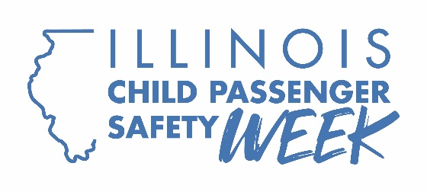

FOR IMMEDIATE RELEASE: [Insert Date]
CONTACT: [Name, Phone Number, Email Address]

[Your Department’s Name] announces Seat Check Saturday numbers

[CITY] – [Your Department’s Name] today announced that Saturday’s National Seat Check event at [location] was a success, with [Number] car seats inspected by certified Illinois Child Passenger Safety Technicians. Of the [Number] car seats checked, only [Number] were found to have been installed correctly before arriving at the event.
“One of the simplest ways to protect your child passengers is to make sure they’re in the right seats and that the seats are installed correctly,” [Organization Spokesperson] said. “After having their kids’ car seats checked and learning more about proper installation, parents and caregivers left knowing how to ensure their children are as safe as possible when riding in a vehicle.”
During the event, parents and caregivers were treated to hands-on demonstrations of proper car seat installation and use and were reminded to register their car seats with manufacturers for notification of recalls. The National Highway Traffic Safety Administration offers the SaferCar app to make getting recall notifications easier.
The free event was [organization]’s way of participating in National Child Passenger Safety Week, which ran from Sept. 20-26. The Illinois Department of Transportation sponsored 77 such events statewide.
For more information on child passenger safety in Illinois, visit www.buckleupillinois.org.
The Child Passenger Safety Week campaign was funded by federal traffic safety funds from NHTSA and administered by IDOT.
###

