(Department/City Letterhead)
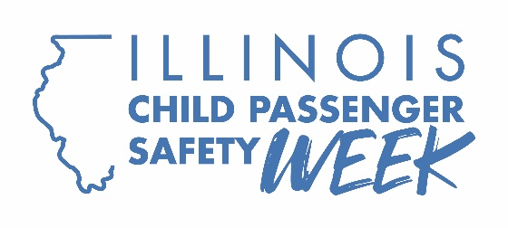

FOR IMMEDIATE RELEASE: [Insert Date]
CONTACT: [Name, Phone Number, Email Address]

[Your department’s name] offering free car seat checks by certified technicians
Sept. 26 is National Seat Check Saturday
[CITY] – (Your Department’s Name) today announced it is partnering with the National Highway Traffic Safety Administration for Child Passenger Safety Week, which runs Sept. 20-26, to help ensure the safety of young children traveling in our community. The annual safety week is capped off with National Seat Check Saturday, where parents and caregivers can get free seat checks and instruction on how to correctly install and use the right car seats for their kids.
“Unfortunately, many parents are overconfident about their car seats,” said [Your Department’s Spokesperson]. “They believe they’re protecting their kids, but nearly half of all car seats are either the wrong seat for the child’s age and size or installed incorrectly. That puts children at risk. Having a certified Child Passenger Safety Technician check your child’s seat can help ensure their safety and give you peace of mind.”
The seat check event, which will take place Sept. 26 at [time/location], is one of 77 sponsored throughout the state by the Illinois Department of Transportation.
According to NHTSA, motor vehicle crashes are a leading cause of death for children. An average of three children were killed, and an estimated 439 children were injured every day in traffic crashes in 2024. Of the 22,713 passenger vehicle occupants killed that year in traffic crashes, 677 were children. Of these 677, restraint use data was available for 585, of whom 229 (39%) were unrestrained. Based on known restraint use, 65% of the children who died in 2024 while riding with unrestrained drivers also were unrestrained.
When it comes to child passengers, there is a right seat for every age and developmental stage, from infants to teens. Whether it’s a rear-facing car seat, a forward-facing car seat installed with a tether, a booster seat or a seat belt, a certified Child Passenger Safety Technician can put parents’ minds at ease by discussing correct car seat selection and showing them how to correctly install that seat in their vehicle. Children should stay in each seat and position until they outgrow those limits, and it’s important for all children under 13 to ride in the back seat.
The campaign is funded by federal traffic safety funds from NHTSA administered by IDOT.

