(Department/City Letterhead)

NEWS 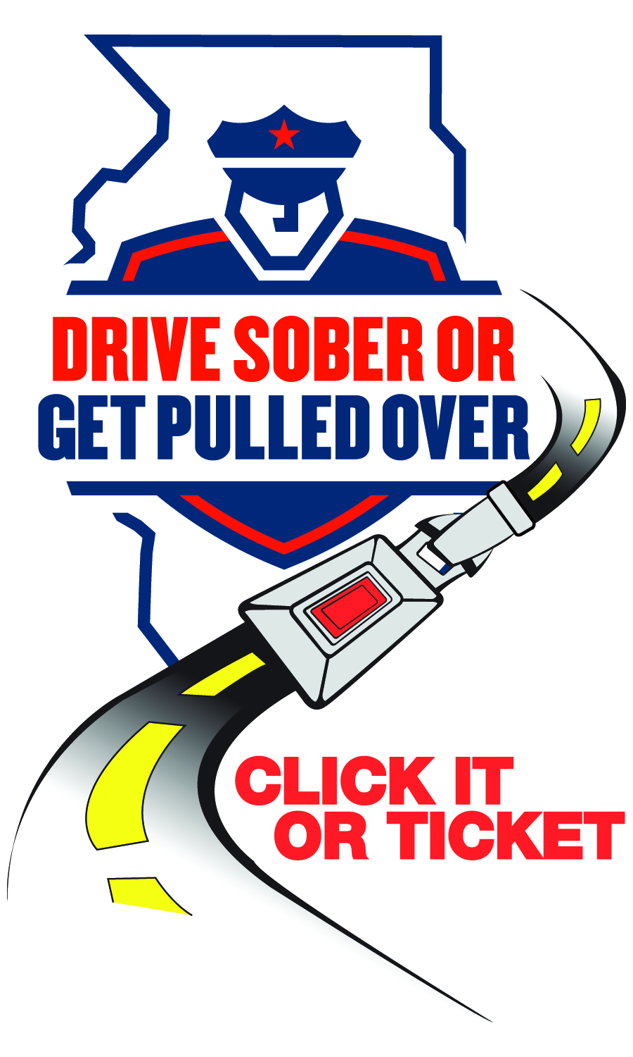
FOR IMMEDIATE RELEASE
Date

For Information, Contact:
Name
Phone Number
Email

[Your Department’s Name] releases Thanksgiving enforcement numbers

[City or County], IL — From Nov. 21 to Dec. 2, [Your Department’s Name] participated in the statewide “Click It or Ticket” and “Drive Sober or Get Pulled Over” mobilization to reduce crashes and save lives. Enforcement focused on seat‑belt use, speeding, distraction, and alcohol‑ and drug‑impaired driving, including cannabis.
During the campaign, [Your Department’s Name] reported:
(insert number) speeding citations
(insert number) occupant restraint citations
(insert number) electronic device use citations
(insert number) DUI (alcohol and/or drugs) arrests
(insert number) other traffic citations
(insert number) traffic arrests
(insert number) criminal arrests

“These results reflect our commitment to a safe community,” said [Your Spokesperson]. “Impaired is impaired, whether you use alcohol, cannabis or other drugs. Combine that with not wearing a seat belt, and the consequences can be deadly. Please buckle up and plan a sober ride every time.”
This Thanksgiving enforcement effort is supported by federal traffic safety funds administered by the Illinois Department of Transportation and aligns with Illinois’ statewide “Drive Sober or Get Pulled Over,” “Click It or Ticket” and “It’s Not a Game” campaigns — because on our roads, it’s not a game.

###

