(Department/City Letterhead)

NEWS 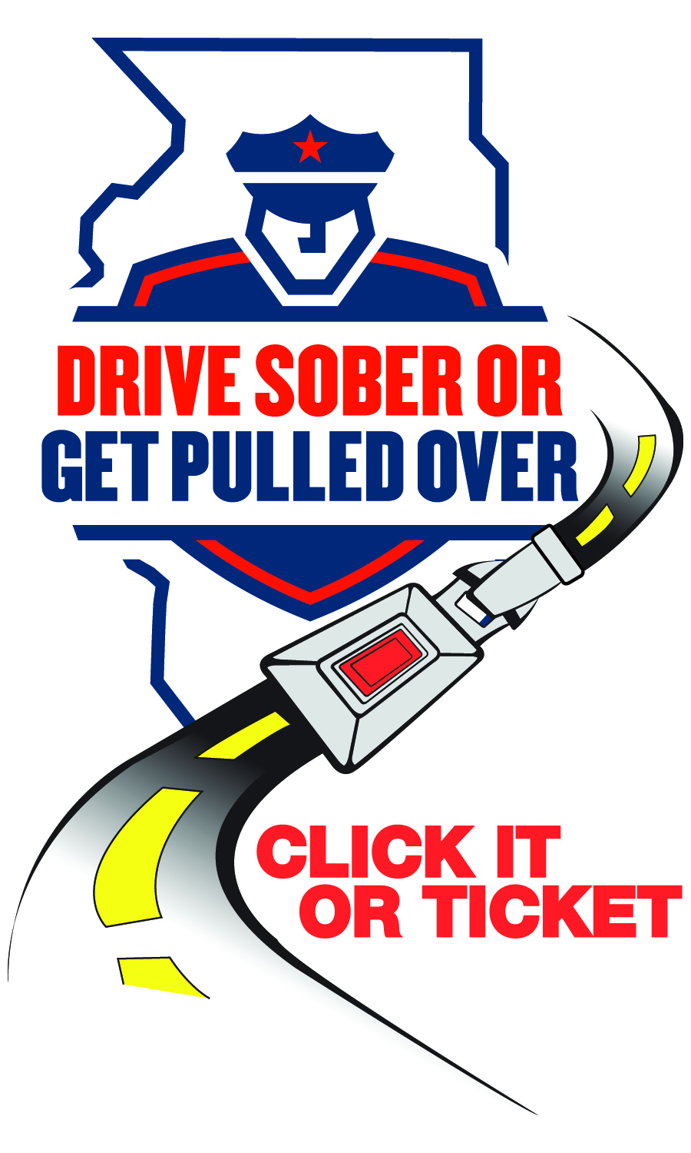
FOR IMMEDIATE RELEASE
Date

For Information, Contact:
Name
Phone Number
Email

(Your Department’s Name) reminds drivers: This Thanksgiving, buckle up and drive sober
[City or County], IL — This Thanksgiving, [Your Department’s Name] is joining the Illinois State Police and local partners to keep holiday travel safe. Our “Click It or Ticket” and “Drive Sober or Get Pulled Over” enforcement campaigns run from Nov. 21 to Dec. 2. Officers will be looking for seat-belt violations, speeding, distracted driving and impaired driving due to alcohol or drugs, including cannabis.
“Thanksgiving brings more vehicles, longer trips and more festivities,” said [Your Department’s Spokesperson]. “Seat belts remain one of the simplest and most effective ways to save your life in a crash. We’re asking every driver and passenger to buckle up, every trip, every time — and to make a plan for a sober ride before the celebrations begin. If you drink alcohol or use cannabis, don’t drive.”
Plan ahead with these tips:
- Before you go out, choose a sober driver or plan to use a taxi, public transit or a rideshare service (Uber, Lyft, etc.).
- If you host, offer alcohol‑free beverages and help guests arrange sober transportation.
- If you’ve used cannabis, do not drive. Effects can be delayed and impair reaction time and judgment.
- If you see an impaired driver on the road, pull over safely and call 911.
- Make sure everyone in the vehicle wears a seat belt. It’s your best defense against an impaired driver.
This Thanksgiving enforcement effort is supported by federal traffic safety funds administered by the Illinois Department of Transportation and aligns with Illinois’ statewide “Drive Sober or Get Pulled Over,” “Click It or Ticket” and “It’s Not a Game” campaigns.

###

